COMPUTER GRAPHICS
MINI PROJECT
DODGING THE ICICLES
Course Code: IT251


Submitted to:

Madam Priyadarshini
Department of Information Technology
NITK Surathkal

Sachin – 15IT234
5th April 2017

Contents:

Cover Page . . . . . . . . . . . . . . . . . . . . . . . . . 1

Contents . . . . . . . . . . . . . . . . . . . . . . . . . 2

Certificate . . . . . . . . . . . . . . . . . . . . . . . . . 3

Synopsis . . . . . . . . . . . . . . . . . . . . . . . . . 4

Introduction . . . . . . . . . . . . . . . . . . . . . . . . . 5

Objective . . . . . . . . . . . . . . . . . . . . . . . . . 6

Methodology . . . . . . . . . . . . . . . . . . . . . . . . . 6

System Specifications . . . . . . . . . . . . . . . . . . . . . . . . . 7

Work done (screenshots) . . . . . . . . . . . . . . . . . . . . . . . . . 8-9

Future Works . . . . . . . . . . . . . . . . . . . . . . . . . 10

Result and discussion . . . . . . . . . . . . . . . . . . . . . . . . . . 10

Conclusion . . . . . . . . . . . . . . . . . . . . . . . . . 11

References . . . . . . . . . . . . . . . . . . . . . . . . . 12

Appendix (code) . . . . . . . . . . . . . . . . . . . . . . . . . . 13-24

(This document consists of 24 pages in total, including both the cover pages.)

Certificate:

This is to certify that the B-Tech Mini project entitled “CG MINI PROJECT” submitted by : Sachin (Roll No.: 15IT234),]as the record of the work carried out by then is accepted as the B-Tech Mini project submission in partial fulfilment of the requirements for mandatory learning course of IT251, Computer Graphics in the Department of Information Technology.

Synopsis:

OpenGL is a very important open source library for programmers who wish to work with graphics. OpenGL can work with 2D and 3D images. OpenGL helps to get a virtual view of real world objects and also helps in visualization of objects. Icicles game is an Open-GL based "old-type" 2D game. It consists of a player in an environment where ice cubes are falling from sky. If the player collides with any of the ice cube then game is over. The player score is the no. of ice cube which he/she can dodge.

This game highlights various concepts such as
- Collision-Detection Algorithm
- KeyBoard Input Effect in all the Menu
- Double Buffer to achieve flicker-free animation. High FPS (60 FPS)
- All Basic OpenGL function has been used
- Settings and high score saved using files

Problem Statement:

“Icicles Game using OpenGL in C++”

Introduction:

In this project “ DODGING THE ICICLES GAME”, the project is programmed using
c/c++. Oops concepts are explored and the project involves the “Man” and “Icicles” on which basis the game is built. This game will be played by only player at time.
USER will be the player. This program contains Functions to draw the iciccles and man, move icicles in a downward fashion with an acceleration and move man the laterally etc.
This project includes the multiple windows, menus using which we can start,quit,pause or resume the game.
The man can be moved laterally by the use of a keyboard only.
It’s a complete strategy game. The main character is ‘a lonely player’ is a human who is lost in a place where dangerous icicles are falling. The player has to dodge each icicle in order to survive. So it’s a matter of life and death for him. Now it must done with the no. of lives that he has been given. The main mission of the gamer/user is to use his reflexes and save the man from the deadly falling icicles. The color of each icicle is changing continously and in a random manner. This makes it even more difficult to dodge icicle for the user.
With each save from the falling icicles the score keeps increasing until the man eventually dies as his life exhaust.
The final score is displayed after the game ends.

The various concepts utilized in the making of the game include
Basic OpenGL Function,
Flicker-Free Animation using Double Buffer,
OOP Concepts ,
Collisoin Detection and basic .

Objective:

- The aim of this project is to develop a graphics package which supports basic operations which include building a 2D GAME using Open GL.
- The package must also has a user-friendly interface.
- The objective of developing this model was to design and apply the skills we learnt in class.
- This game is to entertain the user.
- It may also improve the reflexes of the user as the game requires quick thinking as to how to save the man from dying.
- The game might be a good time pass.

Methodology:-

The project uses OOP methodology. The game consists of four class:- Player,Icicle,Icicles & Constants.

The “Constants” class consists of static final members which stores useful information such as world width and height, player description & icicle description. These are some data which we might want to change because of the different screen size and hardware problem. It's one of the best practice in OOP.

The “player” class consists of data(position,no. of lives) and methods(render & update). The constructor of this class takes no. of lives as the parameter. The render function draws the player based on relative position of it's head centers. The update function updates when we move the man left or right using the directional keys on keyboard. There is function which is called to ensure the player remains in boundary knows as “inbounds”.

The “Icicle” class is used draw one icicle. It consists of data(position,velocity) and methods
render and update. The render method draws the one icicle based on the relative position of it's sharp point. The update method is called every 16 milliseconds(60FPS). The update is responsible for it's animation. The render method has randomly generates colour of the icicle. The Icicles class is basically used to generate vector of the icicle. The signature of the class matches to Icicle class. The render function draw everys icicle in the vector. The update function adds icicle to vector if it is less than its capacity. The collision of icicles with the player is detected by this method. It also checks for unavailability of the icicle(when it has fallen to the ground) and then erase it from vector.

In the “main” we use a variable game_state to draw various menu such as pause state for pause Menu, play state for play Menu etc. The no. of icicle dodged is stored in the variable icicledodged which serves as the score of of player.

System specifications:

Hardware Requirements :
- Dual Core Processor
- 2GB RAM
- 40GB Hard disk
- Keyboard

Software Requirements :
- Programming language – C/C++ using OpenGL
- Operating system – Linux operating system
- Compiler – C Compiler
- Graphics library – GL/glut.h
- OpenGL 2.0

Functional Requirements :

OpenGL APIs:
If we want to have a control on the flow of program and if we want to interact
with the window system then we use OpenGL API’S. Vertices are represented in the
same manner internally, whether they are specified as two-dimensional or three-
dimensional entities, everything that we do are here will be equally valid in three
dimensions. Although OpenGL is easy to learn, compared with other APIs, it is
nevertheless powerful. It supports the simple three dimensional programs and also
supports the advanced rendering techniques.

GL/glut.h:
We use a readily available library called the OpenGL Utility Toolkit (GLUT),
which provides the minimum functionality that should be expected in any modern
windowing system.
The application program uses only GLUT functions and can be recompiled
with the GLUT library for other window system. OpenGL makes a heavy use of
macros to increase code readability and avoid the use of magic numbers. In most
implementation, one of the include lines.

Works done(screenshots and explaination)

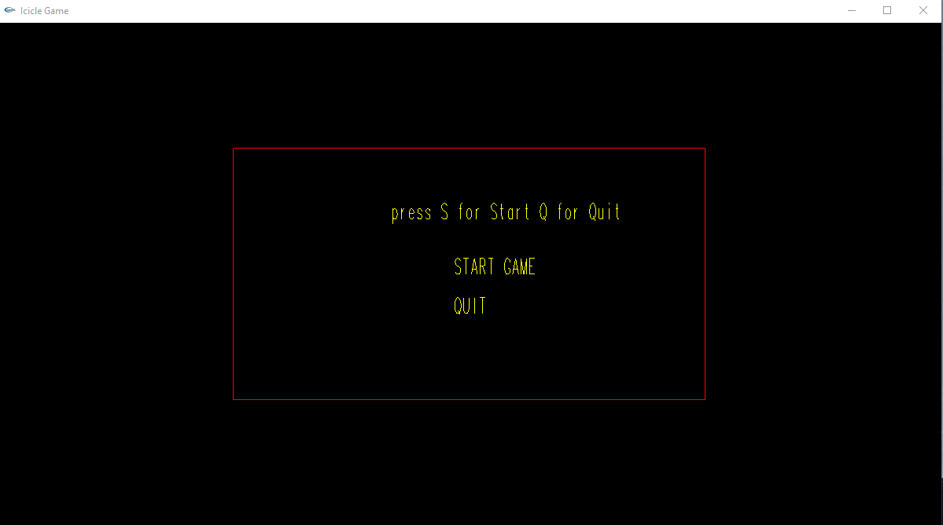
When we start the game:-

As and when we start the game we come across the start menu. Pressing “S” will start the game and pressing “Q” will quit the game.

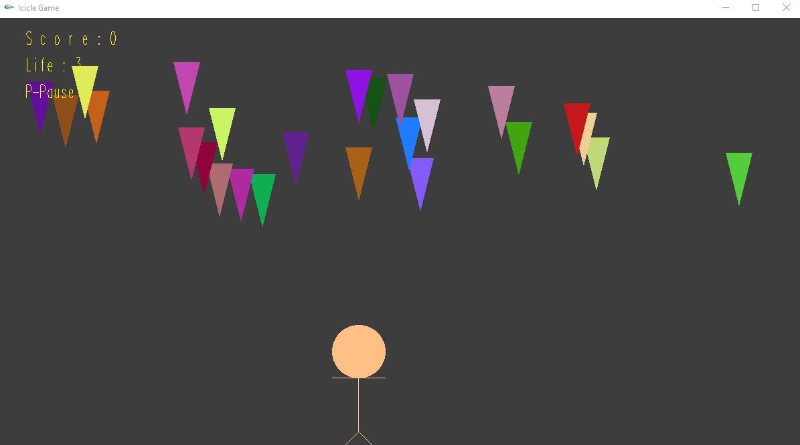
When we press “S” :-
This is the actual game playing screen. Here we move the man left of right in order to dodge the icicles. At the top left corner we see the current score and the lives left before the game ends.
We can pause the game by pressing the “P” button.

When we press “P” :-
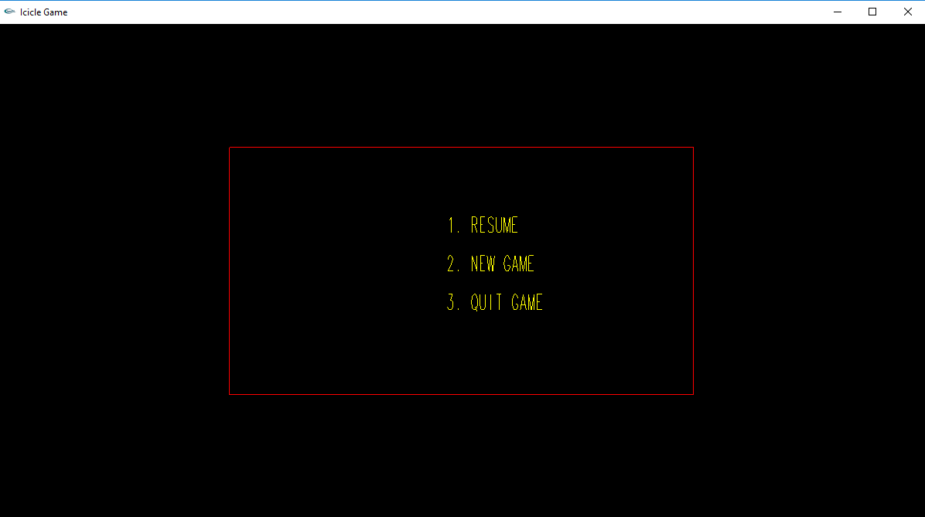
This is the pause menu screen. Here we either choose to resume the game,start a new game which will set score=0 and life=maximum or we can just quit the game.

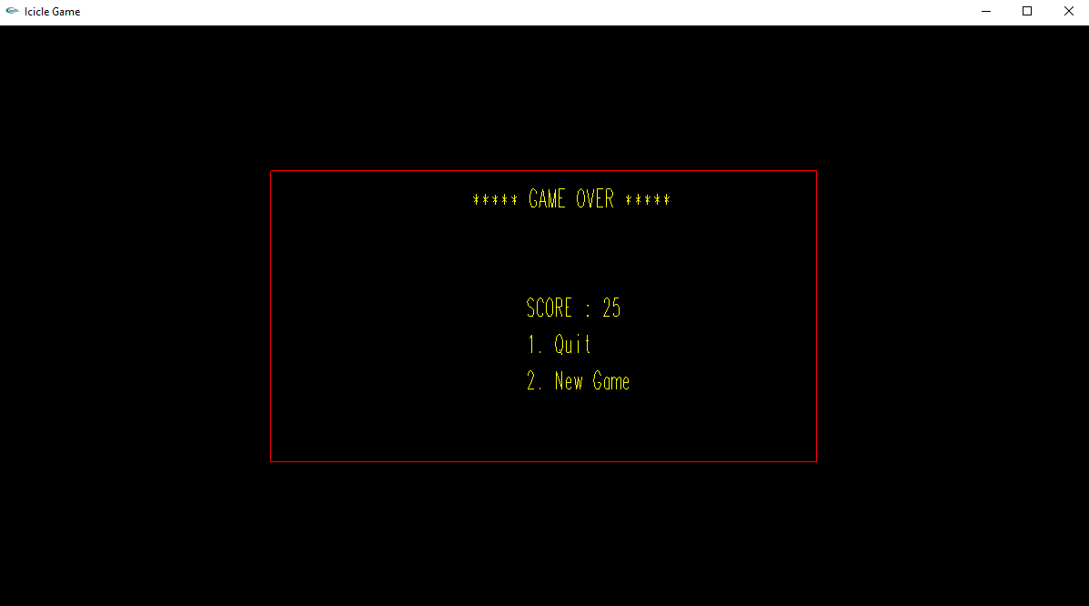
Quitting the game will display this:-

Future works:

- We might make the game more realistic by updating the icicles from being te shape of triangles to actually being a cone which is the actual shape of a triangle.
- To make the game more competetitive we might introduce various difficulty levels, with each level being more difficult and challenging thaan the previous one.
- The game interface would look better if we are able to bring in more 3D objects.
- The project was started with modest aim with no prior experience in any
- programming projects as this, but ended up in learning many things.

Result and Discussion:

- Even though we had no prior knowledge of how to proceed with this project, we put our ideas and creativity at work and succeeded in completing this project.
- It was quite a learning experience and made us familiar as to how open gl and c++ works together.
- This project also helped us create an interest in the field of animations.
- The whole group played an active part of the discussion while making the project.
- A lot of discussion was done in the group before finally deciding on this project.
- As a result, now we have a game which has solely been made by us.

Conclusion

In the fast growing field of software engineering and development and even more rapidly growing sector of game development the future is hard to predict. We are working with this game as our computer graphics project. We choose this type of work for doing better with development cycle, development period, graphics, coding, adopting new technology, animation.
In general software project is a project focusing on the creation of software. Consequently, Success can be measured by taking a look at the resulting software.
In a game project, the product is a game. But and here comes the point: A game is much more than just its software. It has to provide content to become enjoyable. Just like a web server: without content the server is useless, and the quality cannot be measured. This has an important effect on the game project as a whole. The software part of the project is not the only one, and it must be considered in connection to all other parts: The environment of the game, the story, characters, game plays, the artwork, and so on.

References:-

- https://www.udacity.com/course/2d-game-development-with-libgdx--ud405
- https://www.youtube.com/watch?v=Ck1hITwnqec
- http://7petabytes.com/it.books/old/English/Designing%20&%20Graphics/Programming_2D_Games.pdf

Appendix (Code):-

Constant.cpp:-

class Constants{

public:

static const int WORLD_WIDTH = 1700;
static const int WORLD_HEIGHT = 900;

static constexpr float PLAYER_HEAD_RADIUS = 40.0f;
static constexpr float PLAYER_HEAD_HEIGHT = 150.0f ;
static constexpr float PLAYER_LIMB_WIDTH = 0.1f;
static constexpr float PLAYER_MOVEMENT_SPEED = 150.0f;

static constexpr float ICICLES_HEIGHT = 80.0f;
static constexpr float ICICLES_WIDTH = PLAYER_HEAD_RADIUS;
static constexpr float ICICLES_ACCELERATION = -4.0f;

static const int ARRAY_CAPACITY = 25;

};

player.cpp

#include<utility>
#include <iostream>
#include <cmath>
#include "Icicles.cpp"
#ifdef __APPLE__
#include <GLUT/glut.h>
#else
#include <GL/glut.h>
#endif

class Player {

std::pair<float,float> position;
std::pair<float,float> hand;
std::pair<float,float> legs;
int deaths=0;

public:

Player() {
position.first = Constants::PLAYER_HEAD_RADIUS;
position.second = Constants::PLAYER_HEAD_HEIGHT;
}

void update(char key) {
if (key=='l') {
position.first -= /*delta*/0.166 * Constants::PLAYER_MOVEMENT_SPEED;
}
else if (key=='r') {
position.first += /*delta*/0.166 * Constants::PLAYER_MOVEMENT_SPEED;
}

ensureInBounds();
}

private:

void ensureInBounds() {
if (position.first - Constants::PLAYER_HEAD_RADIUS < 0) {
position.first = Constants::PLAYER_HEAD_RADIUS;
}

if (position.first + Constants::PLAYER_HEAD_RADIUS > Constants::WORLD_WIDTH) {
position.first = Constants::WORLD_WIDTH - Constants::PLAYER_HEAD_RADIUS;
}

}

float distance(std::pair<float,float>&p1,std::pair<float,float>&p2){
return sqrt((p1.first-p2.first)*(p1.first-p2.first)+(p1.second-p2.second)*(p1.second-p2.second));
}

public:

bool hitByIcicle(Icicles &icicles) {
bool isHit = false;

for (Icicle icicle : icicles.icicleList) {
if (distance(icicle.position,position) < Constants::PLAYER_HEAD_RADIUS) {
isHit = true;
break;
}
}
if (isHit) {
deaths += 1;
}

return isHit;
}

void render() {

glColor3f(1,192.0/255,134.0/255);
glBegin(GL_TRIANGLE_FAN);
int segment = 1000;
glVertex2f(position.first,position.second);
for(int i=0;i<segment;i++){
float angle = i*2*3.142/segment;
glVertex2f(position.first+Constants::PLAYER_HEAD_RADIUS*cos(angle),position.second+Constants::PLAYER_HEAD_RADIUS*sin(angle));
}
glEnd();

hand.first = position.first;
hand.second = position.second - Constants::PLAYER_HEAD_RADIUS;

legs.first = position.first;
legs.second = position.second - 3 * Constants::PLAYER_HEAD_RADIUS;

glBegin(GL_LINES);
glVertex2f(hand.first,hand.second);
glVertex2f(legs.first,legs.second);
glEnd();

glBegin(GL_LINES);
glVertex2f(hand.first - Constants::PLAYER_HEAD_RADIUS,hand.second);
glVertex2f(hand.first + Constants::PLAYER_HEAD_RADIUS, hand.second);
glEnd();

glBegin(GL_LINES);
glVertex2f(legs.first, legs.second);
glVertex2f(legs.first + Constants::PLAYER_HEAD_RADIUS, legs.second - Constants::PLAYER_HEAD_RADIUS);
glEnd();

glBegin(GL_LINES);
glVertex2f(legs.first, legs.second);
glVertex2f(legs.first - Constants::PLAYER_HEAD_RADIUS, legs.second - Constants::PLAYER_HEAD_RADIUS);
glEnd();

}

};

Icicle.cpp:-

#include<utility>
#include<cmath>
#include<cstdlib>
#include<ctime>
#include "Constants.cpp"
#ifdef __APPLE__
#include <GLUT/glut.h>
#else
#include <GL/glut.h>
#endif

class Icicle {

public:

std::pair<float,float> position;
std::pair<float,float> velocity;
int segment;
float angle;

Icicle(float x,float y) {
position.first = x;
position.second = y;
segment = 1000;
velocity = std::make_pair(0.0f,0.0f);
}

void intit(std::pair<float,float> pos){
time_t t;
srand(time(&t));
position.first = pos.first;
position.second = pos.second;
velocity = std::make_pair(0.0f,0.0f);
}

void update() {
velocity.second += Constants::ICICLES_ACCELERATION * 0.166;
position.second += velocity.second * 0.166;
}

void render() {

glColor3f(static_cast <float> (rand()) / static_cast <float> (RAND_MAX),static_cast <float> (rand()) / static_cast <float> (RAND_MAX)
,static_cast <float> (rand()) / static_cast <float> (RAND_MAX));

glBegin(GL_POLYGON);
glVertex2f(position.first, position.second);
glVertex2f(position.first - Constants::ICICLES_WIDTH / 2, position.second + Constants::ICICLES_HEIGHT);
glVertex2f(position.first + Constants::ICICLES_WIDTH / 2, position.second + Constants::ICICLES_HEIGHT);
glEnd();

}
};

Icicles.cpp:-

#include<vector>
#include "Icicle.cpp"
#include<cstdlib>
#include<ctime>
#include<random>
#include<stdio.h>

class Icicles {

public:
int iciclesDodged;
std::vector<Icicle> icicleList;
char str[100];
Icicles() {
iciclesDodged = 0;
}

void init(int newGame){
if(newGame == 0){
iciclesDodged = 0;
}

icicleList.clear();
}

void update() {

if(icicleList.size() < Constants::ARRAY_CAPACITY ){

icicleList.push_back(Icicle(rand()%Constants::WORLD_WIDTH,Constants::WORLD_HEIGHT));
}

for (int i = 0; i < int(icicleList.size()); i++) {
icicleList[i].update();
}

for (int i = 0; i < int(icicleList.size()); i++) {
if (icicleList[i].position.second < -1*Constants::ICICLES_HEIGHT) {
iciclesDodged += 1;
icicleList.erase(icicleList.begin()+i);
}
}

}

void drawText(int score){
char str[20];

glColor3f(1,1,0);
glPushMatrix();
sprintf(str,"S c o r e : %d",score);
glTranslatef(40,Constants::WORLD_HEIGHT-40,0);
glScalef(.1,.2,.1);
for(int i=0;str[i]!='\0';i++)
glutStrokeCharacter(GLUT_STROKE_MONO_ROMAN,str[i]);
glPopMatrix();

}

void render() {

for (Icicle icicle : icicleList) {
icicle.render();

}
drawText(iciclesDodged);
}
};

Main.cpp:-

#include<windows.h>
#ifdef __APPLE__
#include <GLUT/glut.h>
#else
#include <GL/glut.h>
#endif
#include <stdlib.h>
#include "Player.cpp"
#include <stdio.h>

Player player;
Icicles ics;

int overScore;
int start = 1;
int play = 2;
int pause = 3;
int over = 4;
int resume = 5;
int gamestate = start;
int life = 5;
char str[20];
static void reshape(int width, int height)
{

glViewport(0, 0, width, height);
glMatrixMode(GL_PROJECTION);
glLoadIdentity();
gluOrtho2D(0,width,0,height);
glMatrixMode(GL_MODELVIEW);
glLoadIdentity() ;
}
void timer(int){

if(gamestate == play){
ics.update();
if(player.hitByIcicle(ics)){
if(life == 1){
gamestate = over;
overScore = ics.iciclesDodged;
ics.init(0);
}
ics.init(1);
life -= 1;
}
}

glutPostRedisplay();
glutTimerFunc(16, timer, 0);

}

void drawText(char str[],float x,float y){

glColor3f(1,1,0);
glPushMatrix();
glTranslatef(x,y,0);
glScalef(.1,.2,.1);
for(int i=0;str[i]!='\0';i++)
glutStrokeCharacter(GLUT_STROKE_MONO_ROMAN,str[i]);
glPopMatrix();

}

void gameoverMenu()
{
glClear(GL_COLOR_BUFFER_BIT);
glMatrixMode(GL_MODELVIEW);
glLoadIdentity();
glPushMatrix();
glLoadIdentity();
glColor3f(0,0,0);
glBegin(GL_QUADS);
glVertex2f(0,0);
glVertex2f(Constants::WORLD_WIDTH,0);
glVertex2f(Constants::WORLD_WIDTH,Constants::WORLD_HEIGHT);
glVertex2f(0,Constants::WORLD_HEIGHT);
glEnd();
glPopMatrix();
glPushMatrix();
glColor3f(1,0,0);

glBegin(GL_LINES);
glVertex2f(Constants::WORLD_WIDTH*0.25,Constants::WORLD_HEIGHT*0.75);
glVertex2f(Constants::WORLD_WIDTH*0.75,Constants::WORLD_HEIGHT*0.75);
glEnd();

glBegin(GL_LINES);
glVertex2f(Constants::WORLD_WIDTH*0.25,Constants::WORLD_HEIGHT*0.25);
glVertex2f(Constants::WORLD_WIDTH*0.75,Constants::WORLD_HEIGHT*0.25);
glEnd();

glBegin(GL_LINES);
glVertex2f(Constants::WORLD_WIDTH*0.75,Constants::WORLD_HEIGHT*0.25);
glVertex2f(Constants::WORLD_WIDTH*0.75,Constants::WORLD_HEIGHT*0.75);
glEnd();
glBegin(GL_LINES);
glVertex2f(Constants::WORLD_WIDTH*0.25,Constants::WORLD_HEIGHT*0.25);
glVertex2f(Constants::WORLD_WIDTH*0.25,Constants::WORLD_HEIGHT*0.75);
glEnd();

glPopMatrix();

sprintf(str,"***** GAME OVER *****");
drawText(str,Constants::WORLD_WIDTH/2-80,Constants::WORLD_HEIGHT * 0.75-40);

sprintf(str,"SCORE : %d ",overScore);
drawText(str,Constants::WORLD_WIDTH/2-20,Constants::WORLD_HEIGHT/2);

sprintf(str,"1. Quit");
drawText(str,Constants::WORLD_WIDTH/2-20,Constants::WORLD_HEIGHT/2-40);

sprintf(str,"2. New Game");
drawText(str,Constants::WORLD_WIDTH/2-20,Constants::WORLD_HEIGHT/2-80);

}

void startMenu()
{
glClear(GL_COLOR_BUFFER_BIT);
glMatrixMode(GL_MODELVIEW);
glLoadIdentity();
glPushMatrix();
glLoadIdentity();
glColor3f(0,0,0);

glBegin(GL_QUADS);
glVertex2f(0,0);

glVertex2f(Constants::WORLD_WIDTH,0);
glVertex2f(Constants::WORLD_WIDTH,Constants::WORLD_HEIGHT);
glVertex2f(0,Constants::WORLD_HEIGHT);
glEnd();
glPopMatrix();
glPushMatrix();
glColor3f(1,0,0);

glBegin(GL_LINES);
glVertex2f(Constants::WORLD_WIDTH*0.25,Constants::WORLD_HEIGHT*0.75);
glVertex2f(Constants::WORLD_WIDTH*0.75,Constants::WORLD_HEIGHT*0.75);
glEnd();

glBegin(GL_LINES);
glVertex2f(Constants::WORLD_WIDTH*0.25,Constants::WORLD_HEIGHT*0.25);
glVertex2f(Constants::WORLD_WIDTH*0.75,Constants::WORLD_HEIGHT*0.25);
glEnd();

glBegin(GL_LINES);
glVertex2f(Constants::WORLD_WIDTH*0.75,Constants::WORLD_HEIGHT*0.25);
glVertex2f(Constants::WORLD_WIDTH*0.75,Constants::WORLD_HEIGHT*0.75);
glEnd();

glBegin(GL_LINES);
glVertex2f(Constants::WORLD_WIDTH*0.25,Constants::WORLD_HEIGHT*0.25);
glVertex2f(Constants::WORLD_WIDTH*0.25,Constants::WORLD_HEIGHT*0.75);
glEnd();

glPopMatrix();
sprintf(str,"press S for Start Q for Quit");
drawText(str,Constants::WORLD_WIDTH/2-100,Constants::WORLD_HEIGHT/2+70);

sprintf(str,"START GAME");
drawText(str,Constants::WORLD_WIDTH/2-20,Constants::WORLD_HEIGHT/2);

sprintf(str,"QUIT");
drawText(str,Constants::WORLD_WIDTH/2-20,Constants::WORLD_HEIGHT/2-50);

}

void pauseMenu(){

glClear(GL_COLOR_BUFFER_BIT);
glMatrixMode(GL_MODELVIEW);
glLoadIdentity();
glPushMatrix();
glLoadIdentity();
glColor3f(0,0,0);

glBegin(GL_QUADS);
glVertex2f(0,0);
glVertex2f(Constants::WORLD_WIDTH,0);
glVertex2f(Constants::WORLD_WIDTH,Constants::WORLD_HEIGHT);
glVertex2f(0,Constants::WORLD_HEIGHT);
glEnd();
glPopMatrix();
glPushMatrix();
glColor3f(1,0,0);

glBegin(GL_LINES);
glVertex2f(Constants::WORLD_WIDTH*0.25,Constants::WORLD_HEIGHT*0.75);
glVertex2f(Constants::WORLD_WIDTH*0.75,Constants::WORLD_HEIGHT*0.75);
glEnd();

glBegin(GL_LINES);
glVertex2f(Constants::WORLD_WIDTH*0.25,Constants::WORLD_HEIGHT*0.25);
glVertex2f(Constants::WORLD_WIDTH*0.75,Constants::WORLD_HEIGHT*0.25);
glEnd();

glBegin(GL_LINES);
glVertex2f(Constants::WORLD_WIDTH*0.75,Constants::WORLD_HEIGHT*0.25);
glVertex2f(Constants::WORLD_WIDTH*0.75,Constants::WORLD_HEIGHT*0.75);
glEnd();

glBegin(GL_LINES);
glVertex2f(Constants::WORLD_WIDTH*0.25,Constants::WORLD_HEIGHT*0.25);
glVertex2f(Constants::WORLD_WIDTH*0.25,Constants::WORLD_HEIGHT*0.75);
glEnd();

sprintf(str,"1. RESUME");
drawText(str,Constants::WORLD_WIDTH/2-20,Constants::WORLD_HEIGHT/2+50);

sprintf(str,"2. NEW GAME");
drawText(str,Constants::WORLD_WIDTH/2-20,Constants::WORLD_HEIGHT/2);

sprintf(str,"3. QUIT GAME");
drawText(str,Constants::WORLD_WIDTH/2-20,Constants::WORLD_HEIGHT/2-50);

}

static void display(void)
{
if(gamestate == play ){
glClear(GL_COLOR_BUFFER_BIT);
glMatrixMode(GL_MODELVIEW);
glClearColor(0.24,0.24,0.24,0);

player.render();
ics.render();
sprintf(str,"Life : %d ",life);
drawText(str,40,Constants::WORLD_HEIGHT-80);

sprintf(str,"P-Pause");
drawText(str,40,Constants::WORLD_HEIGHT-120);
}

else if(gamestate == start){
startMenu();

}

else if(gamestate == pause){
pauseMenu();
}

else if (gamestate == over){
gameoverMenu();

}

glutSwapBuffers();

}

static void idle(void)
{
glutPostRedisplay();
}

static void key(int key, int x, int y)
{
switch (key)
{
case GLUT_KEY_RIGHT:
if(gamestate == play) {player.update('r');}
break;

case GLUT_KEY_LEFT:
if(gamestate == play) {player.update('l');}
break;

}

glutPostRedisplay();
}

static void normalKey(unsigned char key, int x, int y)
{
switch (key)
{
case 's':
case 'S':
if(gamestate == start) {gamestate = play;}
break;

case 'p':
case 'P':
if(gamestate == play) {gamestate = pause;}
break;

case '1':
if(gamestate == pause) {gamestate = play;}
if(gamestate == over) {exit(0);}
break;

case '2':
if(gamestate == pause || gamestate == over) {
ics.init(0);
gamestate = play;
life = 5;
}
break;

case '3':
if(gamestate == pause) {exit(0);}

case 'q':
if(gamestate == start) {exit(0);}
break;

}

glutPostRedisplay();
}

int main(int argc, char *argv[])
{
glutInit(&argc, argv);
glutInitWindowSize(Constants::WORLD_WIDTH,Constants::WORLD_HEIGHT);
glutInitWindowPosition(50,50);
glutInitDisplayMode(GLUT_RGB | GLUT_DOUBLE | GLUT_DEPTH);

glutCreateWindow("Icicle Game");

glutReshapeFunc(reshape);

glutDisplayFunc(display);

glutKeyboardFunc(normalKey);
glutSpecialFunc(key);

glutIdleFunc(idle);

glutTimerFunc(16,timer,1);

glutMainLoop();

return EXIT_SUCCESS;
}

